**Analysis Report**

**“Emotion Detection from Tweets by BERT”**

**1. Introduction**

**Background:** Social media users express a wide range of emotions in short messages. Automatically detecting these emotions can benefit applications in customer support, mental health monitoring, and more.

**Objective:** Build and analyze a multi-class emotion classifier using a BERT-based transformer model on tweets dataset.

**2. Dataset and Exploration**

**Dataset:** dataset contains ~20,000 English tweets labeled with one of **six emotions**:

(Sadness, joy, love, anger, fear, surprise.)

* ***Explore the dataset***

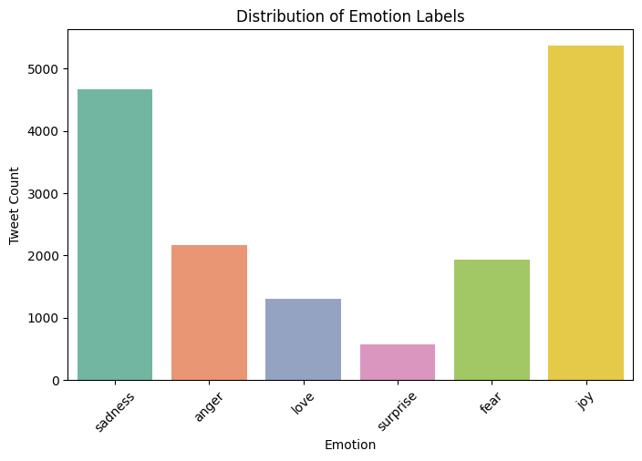

**3. Preprocessing & Tokenization**

1. **Tokenizer.** We use “BERT-base-uncased” tokenizer to map text to token IDs and attention masks.
2. **Padding & Truncation.** Dynamic padding is applied per batch to maximize GPU utilization.

**4. Model and Training Setup**

* **Model.** BertForSequenceClassification with Num labels=6.
* **TrainingArguments.**
  + num_train_epochs=3
  + per_device_train_batch_size=16
  + evaluation_strategy="epoch"
  + fp16=True (mixed precision)
  + run_name="bert-emotion-analysis"

**6. Evaluation:**

- After training, the model achieves ~94 % accuracy on the held-out test set

**7. Conclusion**

* **Summary:** A BERT-based classifier successfully distinguishes six tweet emotions with high accuracy. Visualizations highlighted data balance and training dynamics.